Name ________________________________________
Date ___________________________
Art & Fractions
Directions:
- Use at least 4 different colors to color in the 100 squares in the block.
- You may be creative and make a pattern or a picture in your “art work”.
- Fill out the table to determine the fraction, decimal and percent of each color.
- Share your work with a classmate to try to catch any errors or have Sr. Sherly check your work.
- Once you have filled out your table, cut out your block and your table and attach them to a piece of construction paper.
- Fill out the other table and attach it to the back of your construction paper before turning it in.

COLOR | NUMBER of blocks out of 100 | FRACTION (simplified) | DECIMAL | PERCENT

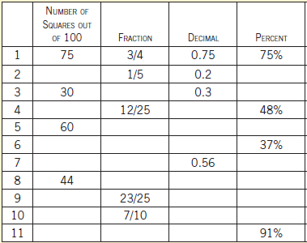

Art and Rational Numbers - 6th Grade Math Project (50 points)
Once you finish this basic example, take a sheet of graph paper and choose a “block” that does not equal 100 squares. Complete the same process as your classwork with 4 or more colors and fill out the table below. Attach your artwork to the construction paper along with your table.
Creativity and neatness: up to 5 points
Challenging choice of block: up to 5 points (for example, 50 squares would not earn you the full 5 points because the calculations are very similar to the 100 squares.)
Accuracy of calculations: 40 points (10 points for each column)
Due: Thursday, 10/23/14
COLOR | NUMBER of blocks out of ______ | FRACTION (simplified) | DECIMAL  (rounded to thousandths) | PERCENT  (rounded to tenths place)

